Holy Trinity Church Walton
The Jammy Biscuit & Cake Competition – 18 July 2026
Show Schedule and Information for Competitors:

Section A: Baking Classes & Recipes:
The five Classes are “Open to all”

- Class 1: Jammy Biscuits – Must be made to own Liz Selway’s recipe as provided. Although the jam is not specified in the recipe Liz always brought them to Church with ‘red’ jam.
Six biscuits must be presented for judging.

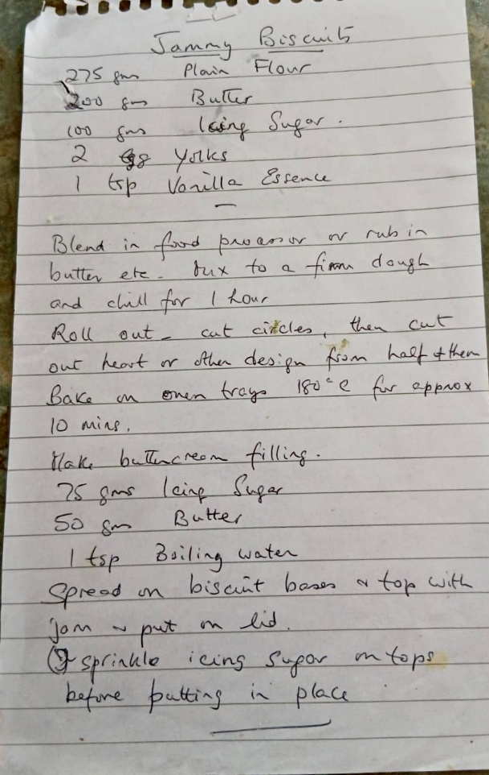
Liz’s Recipe for Jammy Biscuits:
275 gms Plain Flour
200 gms Butter
100 gms Icing Sugar
2 Egg yolks
1 tsp Vanilla Essence

Blend in a food processor or rub in butter etc.
Mix to a firm dough and chill for 1 hour.
Roll out – cut out circles, then cut out hearts or other design from half of them.
Bake on oven trays 180⁰ for approx. 10 minutes.

Make butter cream filling
75 gms Icing sugar
50 gms Butter
1 tsp Boiling water
Spread on biscuit bases and top with jam – put on lid.

Sprinkle icing sugar on tops before putting in place.

- Class 2: a Fruit Cake – made to the competitors’ own choice of recipe, baked in a standard 1lb loaf tin and presented glazed with no other surface decoration.
- Class 3: a Victoria Sponge – made to the competitors’ choice of recipe baked in a 8” round sponge tin with two layers, with ’jam and cream’ filling but with no surface decoration other than a light dusting of icing sugar.
- Class 4: Fruit Scones - made to the competitors’ choice of recipe – 4 must be presented for judging.
- Class 5: Savoury Scones - made to the competitors’ choice of recipe - 4 must be presented for judging.

Section B: How to enter:
- Decide which Classes you are going to enter but you can only make one entry in each class.
- Cut and Complete the ENTRY FORM, at the end of this document. The entry form must list all the exhibits you intend to enter.
- Return your ENTRY FORM by Wednesday 8th July 2026 to register your entries. Preferably return it by email to: waltonbake2026@gmail.com. Alternatively, entry forms can be left, in an envelope marked “Walton Bake”, by Wednesday 8th July 2026 at one of our Churches, either Holy Trinity Church, Walton, Street Parish Church, Street Mission Church, or at St Andrew’s Church Compton Dundon,
- Entry forms submitted after 8 July 2026 will not be accepted. The organisers take no responsibility for entry forms lost or misplaced.
- On the day of the show, Saturday 18th July, between 9.00 and 10:00am bring your entry to Walton Church together with the ENTRY FEE – one entry costs £5, 2 entries £8, 3 or more entries £10.
- You will be provided with a paper plate for each of your entries together with a sticky label to anonymously identify your entry. You will be directed to the staging area.
- No exhibits will be accepted after 10:00 and staging of exhibits must be completed by 10:15am. Show Stewards will assist you in staging your entry/entries.
- Having staged their entries all competitors who are not part of the Show staff MUST leave the Church so that Judging can commence at 10:20am.
- Competitors are invited to return to the Church when the competition is opened to the public to view the exhibits at 2:00pm.
- Presentation of prizes will take place 3:15pm
- The event will close at 3:30pm
- Exhibitors may retrieve their exhibits between 3:30 – 3:45pm - any unclaimed exhibits will be distributed by the organisers as they feel appropriate.

Section C: Competition Rules:
- All entries must be registered by Wednesday 8th July 2026 using the ENTRY FORM.
- All entries must be the competitors’ own individual work.
- Late entries or entries without the required entry fee will not be accepted.
- Entries must be presented (staged) on a white paper plate provided by the show and with the provided adhesive label attached to the plate.
- No other label or means of identification may be placed on any part of the entry
- Competitors may make only one entry per class. Competitors may enter as many or as few classes as they wish.
- No entry may be removed before the end of the show without the permission of the Head Steward
- Every reasonable care will be taken of entries, but the Show Organisers are not responsible for any loss or damage that may in anyway occur.
- All entries must be collected, by their respective competitor, at the close of the show.

Section D: Judging:
- All entries will be judged on three criteria: -
- External Appearance (neither burnt nor undercooked)
- Quality of Baking (no soggy bottoms, etc.), and
- Flavour and Aroma
- The Judges will decide the relative importance of these criteria. If standard is considered below par, the Judges may decide to limit the number of awards in each class. In all circumstances the Judges’ decision is final.

Section E: Awards and Prizes:
In each class the Judges may award a certificate, or not as they decide, for 1st, 2nd, and 3rd place.
The competitor awarded a 1st place certificate will receive 5 points, the 2nd 3 points and the 3rd 1 point towards the “Points Prize”.
Competitors entered in Class 1 will each receive 5 points towards the “Point Prize”. Competitors entered in the other Classes (2 to 5) will receive 2 points towards the “Point Prize” for each class entered.
The “Jammy Biscuit Prize” will be awarded to Competitor who comes 1st in Class 1.
The “Best in Show Prize” will be awarded to the Competitor whose entry the Judges consider is best of those awarded a 1st place.
The “Points Prize” will be awarded to the Competitor that has accumulated most points. Before the competition starts the Organiser will agree with the Judges how a tie of point might be resolved.
The winner/s of the “Jammy Biscuit Prize”, “Points Prize” and the “Best in Show” will be announced at the end of the Show.
__________________________________________ cut here __________________________________________ Entry Form for The Jammy Biscuit & Cake Competition – Return by 8 July 2026
Competition on Saturday 18th July 2026 at Holy Trinity Church, Walton

Your Name: | Tel:
Address: | Email:

Fill in below the Class Number and Description for each of the Class/es you intend to enter
Class No. | Class Description (please use one line for each entry) | Office use
Completed Entry forms must submitted by Wednesday 8th July 2026 either by email to waltonbake2026@gmail.com or returned to one of our churches - Holy Trinity Church, Walton, Street Parish Church, Street Mission Church, and at St Andrew’s Church Compton Dundon.
Late Entry Forms will not be accepted

